Chauhan Uday
introduction to sql

1. Introduction to SQL
LAB EXERCISES:
Lab 3: Create a database called library_db and a table books with columns: book_id, title, author, publisher, year_of_publication, and price. Insert five records into the table.
CREATE DATABASE library_db;
CREATE TABLE books (book_id INT AUTO_INCREMENT PRIMARY KEY,title VARCHAR(100) NOT NULL,author VARCHAR(50) NOT NULL,publisher VARCHAR(50),year_of_publication YEAR,price DECIMAL(8,2));
INSERT INTO books (title, author, publisher, year_of_publication, price) VALUES
('The Alchemist', 'Paulo Coelho', 'HarperOne', 1988, 250.00)
INSERT INTO books (title, author, publisher, year_of_publication, price) VALUES
('1984', 'George Orwell', 'Secker & Warburg', 1949, 300.00)
INSERT INTO books (title, author, publisher, year_of_publication, price) VALUES
('To Kill a Mockingbird', 'Harper Lee', 'J.B. Lippincott & Co.', 1960, 350.00)
INSERT INTO books (title, author, publisher, year_of_publication, price) VALUES
('The Great Gatsby', 'F. Scott Fitzgerald', 'Scribner', 1925, 280.00)
INSERT INTO books (title, author, publisher, year_of_publication, price) VALUES
('Moby Dick', 'Herman Melville', 'Harper & Brothers', 1851, 400.00);
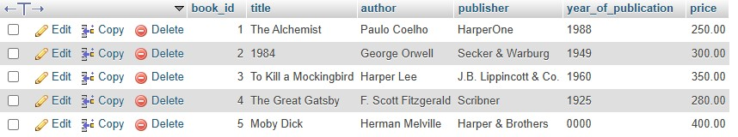
CREATE TABLE members (member_id INT PRIMARY KEY AUTO_INCREMENT,member_name
VARCHAR(100),date_of_membership DATE,email VARCHAR(100));
INSERT INTO members (member_id, member_name, date_of_membership, email) VALUES
(1, 'Rana Vrujal', '2025-01-10', 'rana.vrujal@example.com');
INSERT INTO members (member_id, member_name, date_of_membership, email) VALUES
(2, 'Jaydeep Dama', '2025-02-15', 'jaydeep.dama@example.com');
INSERT INTO members (member_id, member_name, date_of_membership, email) VALUES
(3, 'Meera Patel', '2025-03-05', 'meera.patel@example.com');
INSERT INTO members (member_id, member_name, date_of_membership, email) VALUES
(4, 'Kiran Shah', '2025-04-12', 'kiran.shah@example.com');
INSERT INTO members (member_id, member_name, date_of_membership, email) VALUES
(5, 'Anjali Desai', '2025-05-20', 'anjali.desai@example.com');
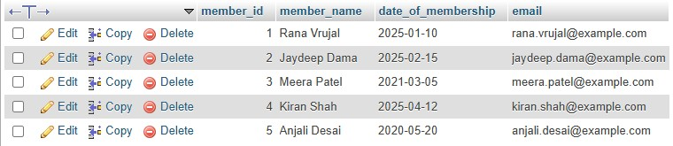

2. SQL Syntax
LAB EXERCISES:
Lab 3: Retrieve all members who joined the library before 2022. Use appropriate SQL syntax with WHERE and ORDER BY.
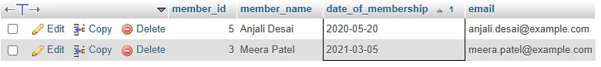

Lab 4: Write SQL queries to display the titles of books published by a specific author. Sort the results by year_of_publication in descending order.
SELECT title FROM books WHERE author = 'Paulo Coelho' ORDER BY year_of_publication DESC;
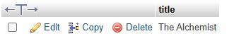

3. SQL Constraints
LAB EXERCISES:
Lab 3: Add a CHECK constraint to ensure that the price of books in the books table is greater than 0.
ALTER TABLE books ADD CONSTRAINT chk_price_positive CHECK (price > 0);
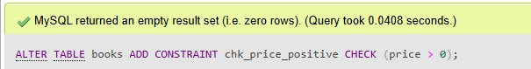
Lab 4: Modify the members table to add a UNIQUE constraint on the email column, ensuring that each member has a unique email address.
ALTER TABLE members ADD CONSTRAINT unique_email UNIQUE (email);
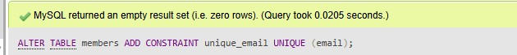

4. Main SQL Commands and Sub-commands (DDL)
LAB EXERCISES:
Lab 3: Create a table authors with the following columns: author_id, first_name, last_name, and country. Set author_id as the primary key.
CREATE TABLE authors (author_id INT PRIMARY KEY AUTO_INCREMENT,first_name VARCHAR(50),last_name VARCHAR(50),country VARCHAR(50));
INSERT INTO authors (author_id, first_name, last_name, country) VALUES
(1, 'Paulo', 'Coelho', 'Brazil');
INSERT INTO authors (author_id, first_name, last_name, country) VALUES
(2, 'George', 'Orwell', 'United Kingdom');
INSERT INTO authors (author_id, first_name, last_name, country) VALUES
(3, 'Harper', 'Lee', 'United States');
INSERT INTO authors (author_id, first_name, last_name, country) VALUES
(4, 'F. Scott', 'Fitzgerald', 'United States');
INSERT INTO authors (author_id, first_name, last_name, country) VALUES
(5, 'Herman', 'Melville', 'United States');
SELECT * FROM authors;
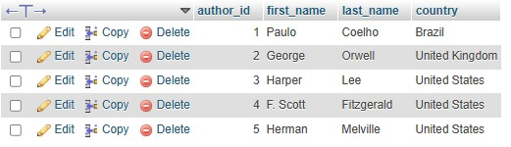
Lab 4: Create a table publishers with columns: publisher_id, publisher_name, contact_number, and address. Set publisher_id as the primary key and contact_number as unique.
CREATE TABLE publishers ( publisher_id INT PRIMARY KEY,publisher_name VARCHAR(100),contact_number VARCHAR(20) UNIQUE,address VARCHAR(200));

INSERT INTO publishers (publisher_id, publisher_name, contact_number, address) VALUES
(1, 'HarperOne', '1234567890', '123 Main St, New York');
INSERT INTO publishers (publisher_id, publisher_name, contact_number, address) VALUES
(2, 'Secker & Warburg', '2345678901', '45 High St, London');
INSERT INTO publishers (publisher_id, publisher_name, contact_number, address) VALUES
(3, 'J.B. Lippincott & Co.', '3456789012', '67 Market St, Philadelphia');
INSERT INTO publishers (publisher_id, publisher_name, contact_number, address) VALUES
(4, 'Scribner', '4567890123', '89 Broadway, New York');
INSERT INTO publishers (publisher_id, publisher_name, contact_number, address) VALUES (5, 'Harper & Brothers', '5678901234', '101 Wall St, New York');

SELECT * FROM publishers;
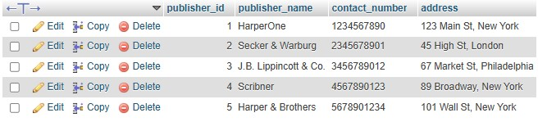

5. ALTER Command
LAB EXERCISES:
Lab 3: Add a new column genre to the books table. Update the genre for all existing records.
ALTER TABLE books ADD genre VARCHAR(50);
UPDATE books SET genre = 'Fiction' WHERE book_id = 1;
UPDATE books SET genre = 'Dystopian' WHERE book_id = 2;
UPDATE books SET genre = 'Classic' WHERE book_id = 3;
UPDATE books SET genre = 'Classic' WHERE book_id = 4;
UPDATE books SET genre = 'Adventure' WHERE book_id = 5;
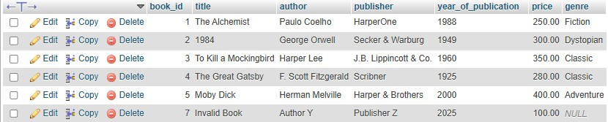
Lab 4: Modify the members table to increase the length of the email column to 100 characters. ALTER TABLE members MODIFY email VARCHAR(100);
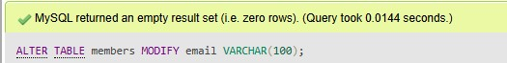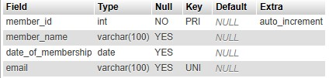

6. DROP Command
LAB EXERCISES:
Lab 3: Drop the publishers table from the database after verifying its structure. DROP TABLE publishers;
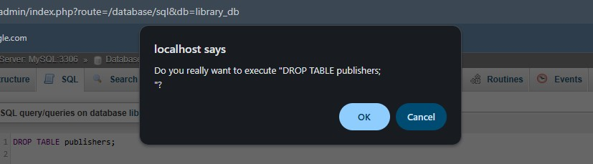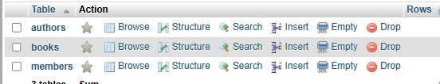

CREATE TABLE members_backup AS
SELECT * FROM members;
SHOW TABLES;
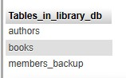
SELECT * FROM `members_backup`
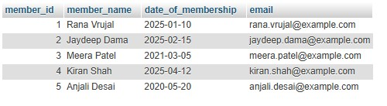

7. Data Manipulation Language (DML)
LAB EXERCISES:
Lab 4: Insert three new authors into the authors table, then update the last name of one of the authors.
INSERT INTO authors (author_id, first_name, last_name, country) VALUES
(6, 'Ravindra', 'Patel', 'India');
INSERT INTO authors (author_id, first_name, last_name, country) VALUES
(7, 'Anita', 'Shah', 'India');
INSERT INTO authors (author_id, first_name, last_name, country) VALUES (8, 'Michael', 'Brown', 'USA');
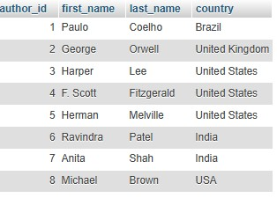
UPDATE authors SET last_name = 'Mehta' WHERE author_id = 7;
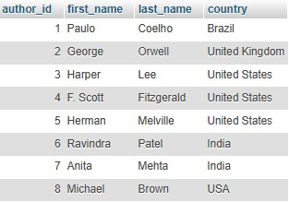
SELECT * FROM authors WHERE author_id = 7;
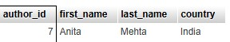
Lab 5: Delete a book from the books table where the price is higher than $100.
DELETE FROM books WHERE price > 100;
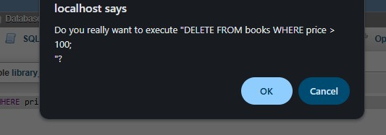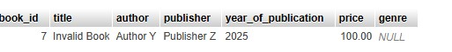

8. UPDATE Command
LAB EXERCISES:
Lab 3: Update the year_of_publication of a book with a specific book_id.
UPDATE books SET year_of_publication = 2021 WHERE book_id = 7;
SELECT * FROM books WHERE book_id = 7;
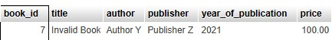
Lab 4: Increase the price of all books published before 2015 by 10%.
UPDATE books SET price = price * 1.10 WHERE year_of_publication < 2015;
SELECT * FROM books WHERE year_of_publication < 2015;
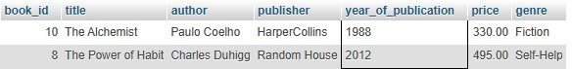

9. DELETE Command
LAB EXERCISES:
Lab 3: Remove all members who joined before 2020 from the members table. SELECT * FROM members WHERE date_of_membership < '2020-01-01';
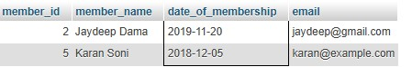
Lab 4: Delete all books that have a NULL value in the author column.
DELETE FROM books WHERE author IS NULL;
SELECT * FROM books WHERE author IS NULL;
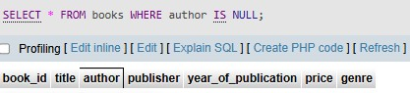

10. Data Query Language (DQL)
LAB EXERCISES:
Lab 4: Write a query to retrieve all books with price between $50 and $100.
SELECT * FROM books WHERE price BETWEEN 50 AND 100;
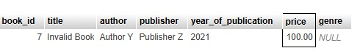
Lab 5: Retrieve the list of books sorted by author in ascending order and limit the results to the top 3 entries. SELECT * FROM books ORDER BY author ASC LIMIT 3;
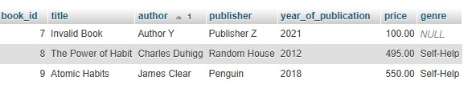

11. Data Control Language (DCL)
LAB EXERCISES:
Lab 3: Grant SELECT permission to a user named librarian on the books table.
Lab 4: Grant INSERT and UPDATE permissions to the user admin on the members table.

12. REVOKE Command
LAB EXERCISES:
Lab 3: Revoke the INSERT privilege from the user librarian on the books table.
Lab 4: Revoke all permissions from user admin on the members table.

13. Transaction Control Language (TCL)
LAB EXERCISES:
Lab 3: Use COMMIT after inserting multiple records into the books table, then make another insertion and perform a ROLLBACK.
START TRANSACTION;

INSERT INTO books (book_id, title, author, publisher, year_of_publication, price) VALUES
(11, 'The Power of Habit', 'Charles Duhigg', 'Random House', 2012, 450);
INSERT INTO books (book_id, title, author, publisher, year_of_publication, price)
VALUES(12, 'Atomic Habits', 'James Clear', 'Penguin', 2018, 550);

COMMIT;
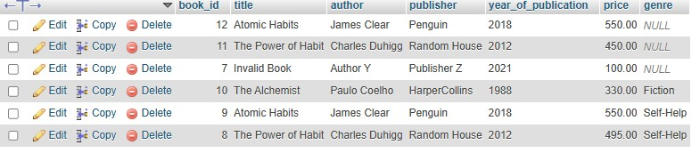
START TRANSACTION;

INSERT INTO books (book_id, title, author, publisher, year_of_publication, price)
VALUES
(13, 'Educated', 'Tara Westover', 'Random House', 2018, 500);

ROLLBACK;
Lab 4: Set a SAVEPOINT before making updates to the members table, perform some updates, and then roll back to the SAVEPOINT.
START TRANSACTION;
SAVEPOINT before_update;
UPDATE members SET member_name = 'Rana V' WHERE member_id = 1;
UPDATE members SET email = 'jaydeep.dama@example.com' WHERE member_id = 2; ROLLBACK TO SAVEPOINT before_update;
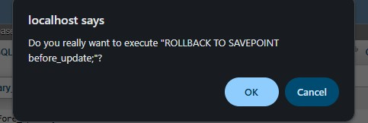

COMMIT; 14. SQL Joins
LAB EXERCISES:
Lab 3: Perform an INNER JOIN between books and authors tables to display the title of books and their respective authors' names.
SELECT b.title, a.first_name, a.last_name
FROM books b
INNER JOIN authors a
ON b.author = CONCAT(a.first_name, ' ', a.last_name);
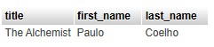
Lab 4: Use a FULL OUTER JOIN to retrieve all records from the books and authors tables, including those with no matching entries in the other table.
SELECT b.title, a.first_name, a.last_name
FROM books b
LEFT JOIN authors a
ON b.author = CONCAT(a.first_name, ' ', a.last_name)

UNION

SELECT b.title, a.first_name, a.last_name
FROM books b
RIGHT JOIN authors a
ON b.author = CONCAT(a.first_name, ' ', a.last_name);
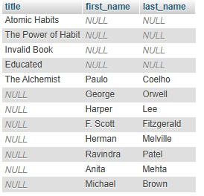

15. SQL Group By
LAB EXERCISES:
Lab 3: Group books by genre and display the total number of books in each genre.
SELECT genre, COUNT(*) AS total_books FROM books GROUP BY genre;
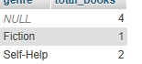
Lab 4: Group members by the year they joined and find the number of members who joined each year.
SELECT YEAR(date_of_membership) AS join_year, COUNT(*) AS total_members
FROM members
GROUP BY YEAR(date_of_membership)
ORDER BY join_year;
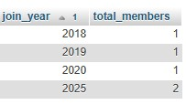

16. SQL Stored Procedure
LAB EXERCISES:
Lab 3: Write a stored procedure to retrieve all books by a particular author.
DELIMITER $$

CREATE PROCEDURE get_books_by_author(IN author_name VARCHAR(100))
BEGIN
SELECT *
FROM books
WHERE author = author_name;
END $$

DELIMITER ;
CALL get_books_by_author('Paulo Coelho');
Lab 4: Write a stored procedure that takes book_id as an argument and returns the price of the book. DELIMITER $$

CREATE PROCEDURE get_book_price(IN b_id INT, OUT book_price DECIMAL(10,2))
BEGIN
SELECT price INTO book_price
FROM books
WHERE book_id = b_id;
END $$

DELIMITER ;
CALL get_book_price(9, @price);
SELECT @price AS book_price;
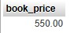

17. SQL View
LAB EXERCISES:
Lab 3: Create a view to show only the title, author, and price of books from the books table.

CREATE VIEW book_summary AS
SELECT title, author, price
FROM books;
SELECT * FROM book_summary;
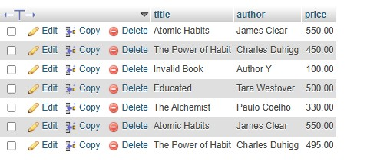
Lab 4: Create a view to display members who joined before 2020.
CREATE VIEW members_before_2020 AS
SELECT *
FROM members
WHERE date_of_membership < '2020-01-01';
SELECT * FROM members_before_2020;
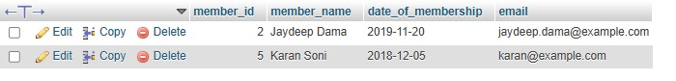

18. SQL Trigger
LAB EXERCISES:
Lab 3: Create a trigger to automatically update the last_modified timestamp of the books table whenever a record is updated.
ALTER TABLE books
ADD COLUMN last_modified TIMESTAMP DEFAULT CURRENT_TIMESTAMP ON UPDATE CURRENT_TIMESTAMP;

DELIMITER $$

CREATE TRIGGER update_last_modified
BEFORE UPDATE ON books
FOR EACH ROW
BEGIN
SET NEW.last_modified = CURRENT_TIMESTAMP;
END $$

DELIMITER ;

UPDATE books
SET price = 500
WHERE book_id = 8;

SELECT book_id, title, price, last_modified
FROM books
WHERE book_id = 8;
Lab 4: Create a trigger that inserts a log entry into a log_changes table whenever a DELETE operation is performed on the books table.
CREATE TABLE log_changes ( log_id INT AUTO_INCREMENT PRIMARY KEY,
book_id INT, title VARCHAR(255), operation VARCHAR(50),
change_time TIMESTAMP DEFAULT CURRENT_TIMESTAMP
);

DELIMITER $$

CREATE TRIGGER log_book_deletion
AFTER DELETE ON books
FOR EACH ROW
BEGIN
INSERT INTO log_changes (book_id, title, operation)
VALUES (OLD.book_id, OLD.title, 'DELETE');
END $$

DELIMITER ;

DELETE FROM books WHERE book_id = 10;

19. Introduction to PL/SQL
LAB EXERCISES:
Lab 3: Write a PL/SQL block to insert a new book into the books table and display a confirmation message. DELIMITER $$

CREATE PROCEDURE insert_new_book(
IN p_title VARCHAR(100),
IN p_author VARCHAR(50),
IN p_publisher VARCHAR(50),
IN p_year YEAR,
IN p_price DECIMAL(8,2)
)
BEGIN
INSERT INTO books (title, author, publisher, year_of_publication, price)
VALUES (p_title, p_author, p_publisher, p_year, p_price);

SELECT CONCAT('Book inserted successfully: ', p_title) AS message; END $$

DELIMITER ;
CALL insert_new_book(
'Harry Potter',
'J.K. Rowling',
'Bloomsbury',
1997,
450.00
);
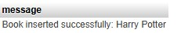
Lab 4: Write a PL/SQL block to display the total number of books in the books table. DELIMITER $$

CREATE PROCEDURE get_total_books()
BEGIN
SELECT COUNT(*) AS total_books FROM books;
END $$

DELIMITER ;
CALL get_total_books();
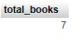

20. PL/SQL Syntax
LAB EXERCISES:
Lab 3: Write a PL/SQL block to declare variables for book_id and price, assign values, and display the results. DELIMITER $$

CREATE PROCEDURE display_values()
BEGIN
DECLARE v_book_id INT DEFAULT 101;
DECLARE v_price DECIMAL(8,2) DEFAULT 299.50;

SELECT v_book_id AS book_id, v_price AS price;
END $$

DELIMITER ;
CALL display_values();
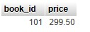
Lab 4: Write a PL/SQL block using constants and perform arithmetic operations on book prices. DELIMITER $$

CREATE PROCEDURE lab4_book_price_operations()
BEGIN
DECLARE price1 DECIMAL(8,2) DEFAULT 250.00; DECLARE price2 DECIMAL(8,2) DEFAULT 150.00;

DECLARE total_price DECIMAL(8,2);
DECLARE difference DECIMAL(8,2);
DECLARE discounted_price DECIMAL(8,2);

SET total_price = price1 + price2;
SET difference = price1 - price2;
SET discounted_price = price1 * 0.90;

SELECT price1 AS Price_1, price2 AS Price_2, total_price AS Total_Price, difference AS Difference, discounted_price AS Discounted_Price;
END $$

DELIMITER ;
CALL lab4_book_price_operations();
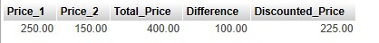

21. PL/SQL Control Structures
LAB EXERCISES:
Lab 3: Write a PL/SQL block using IF-THEN-ELSE to check if a book's price is above $100 and print a message accordingly. DELIMITER $$

CREATE PROCEDURE check_book_price()
BEGIN
DECLARE v_price DECIMAL(8,2) DEFAULT 120;

IF v_price > 100 THEN
SELECT 'The price is above $100' AS message;
ELSE
SELECT 'The price is $100 or below' AS message;
END IF;
END $$

DELIMITER ;
CALL check_book_price();
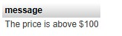
Lab 4: Use a FOR LOOP in PL/SQL to display the details of all books one by one.
DELIMITER $$

CREATE PROCEDURE display_all_books()
BEGIN
DECLARE done INT DEFAULT 0;
DECLARE v_id INT;
DECLARE v_title VARCHAR(100);
DECLARE v_author VARCHAR(100);

DECLARE book_cursor CURSOR FOR
SELECT book_id, title, author FROM books;

DECLARE CONTINUE HANDLER FOR NOT FOUND SET done = 1;

OPEN book_cursor;

read_loop: LOOP
FETCH book_cursor INTO v_id, v_title, v_author;
IF done = 1 THEN
LEAVE read_loop;
END IF;

SELECT v_id AS Book_ID, v_title AS Title, v_author AS Author;
END LOOP;

CLOSE book_cursor;
END $$

DELIMITER ;

22. SQL Cursors
LAB EXERCISES:
Lab 3: Write a PL/SQL block using an explicit cursor to fetch and display all records from the members table. DELIMITER $$

CREATE PROCEDURE display_members()
BEGIN
DECLARE done INT DEFAULT 0;
DECLARE v_id INT;
DECLARE v_name VARCHAR(100);
DECLARE v_join_date DATE;

DECLARE member_cursor CURSOR FOR
SELECT member_id, member_name, join_date FROM members;

DECLARE CONTINUE HANDLER FOR NOT FOUND SET done = 1;

OPEN member_cursor;

read_loop: LOOP
FETCH member_cursor INTO v_id, v_name, v_join_date;
IF done = 1 THEN
LEAVE read_loop;
END IF;

SELECT v_id AS Member_ID, v_name AS Member_Name, v_join_date AS Join_Date; END LOOP;

CLOSE member_cursor;
END $$

DELIMITER ;
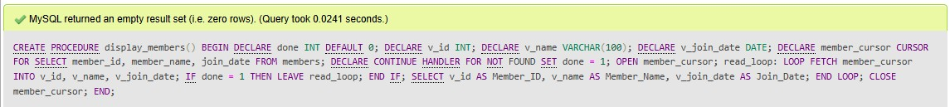
Lab 4: Create a cursor to retrieve books by a particular author and display their titles. DELIMITER $$

DROP PROCEDURE IF EXISTS get_books_by_author$$

CREATE PROCEDURE get_books_by_author(IN p_author VARCHAR(100))
BEGIN
DECLARE done INT DEFAULT 0;
DECLARE v_title VARCHAR(200);

DECLARE book_cursor CURSOR FOR
SELECT title FROM books WHERE author = p_author;

DECLARE CONTINUE HANDLER FOR NOT FOUND SET done = 1;

OPEN book_cursor;

read_loop: LOOP
FETCH book_cursor INTO v_title;
IF done = 1 THEN
LEAVE read_loop;
END IF;

SELECT v_title AS Title;
END LOOP;

CLOSE book_cursor;
END$$

DELIMITER ;
CALL get_books_by_author('Author Name');
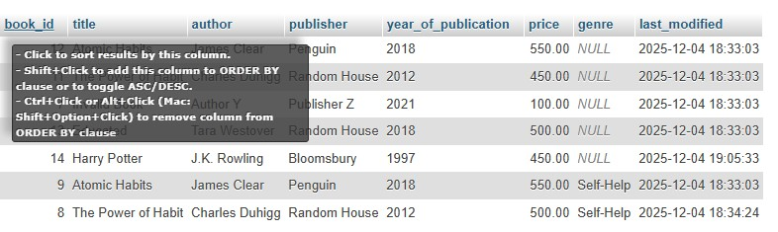

23. Rollback and Commit Savepoint
LAB EXERCISES:
Lab 3: Perform a transaction that includes inserting a new member, setting a SAVEPOINT, and rolling back to the savepoint after making updates.
START TRANSACTION;

INSERT INTO members (member_name, date_of_membership) VALUES ('John Patel', '2024-01-10');

SAVEPOINT sp1;

UPDATE members
SET member_name = 'Temp Name'
WHERE member_name = 'John Patel';

ROLLBACK TO sp1;

COMMIT;
SELECT * FROM members;
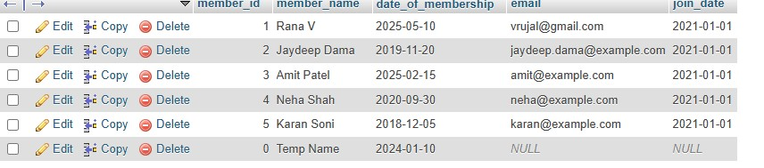
Lab 4: Use COMMIT after successfully inserting multiple books into the books table, then use ROLLBACK to undo a set of changes made after a savepoint.
START TRANSACTION;

INSERT INTO books (title, author, publisher, year_of_publication, price)
VALUES ('Book A', 'Author X', 'Publisher 1', 2020, 300),
('Book B', 'Author Y', 'Publisher 2', 2021, 450),
('Book C', 'Author Z', 'Publisher 3', 2019, 250);

COMMIT;

START TRANSACTION;

SAVEPOINT sp1;

UPDATE books
SET price = price + 50
WHERE author = 'Author X';

UPDATE books
SET price = price + 100
WHERE author = 'Author Y';

ROLLBACK TO sp1;

COMMIT;
SELECT * FROM books;
